Summer 2022



Dear Parents and Future Fifth Grader,

Welcome to Fifth Grade! My name is Mrs. Monica Kelly and I am thrilled to have you in my class this year! I am really looking forward to starting this school year together!

I would like to take this opportunity to introduce myself to you. I graduated from Muhlenberg College with a degree in both Elementary Education and English. I received my Master’s Degree in Educational Administration from Rider University in 2008, and my Special Education Certification from St. Joseph’s University in the spring of 2012. This will be my eighteenth year teaching in the Central Bucks School District and my fourteenth year in fifth grade!

Hopefully your summer has been a relaxing and enjoyable one. I spent my summer vacation with family and friends on Long Beach Island. I have enjoyed reading many books, boating, and spending long days on the beach this summer! As the summer comes to a close, I am eagerly anticipating a new year of adventure, growth, learning, and friendship. Fifth grade will be a wonderful and truly memorable experience.

The first few weeks of school will be spent building our classroom community and establishing a culture of respect, responsibility, collaboration, and citizenship. We have a lot of fun in fifth grade, but we also work **very hard**. As a fifth grader, you will learn a lot of important reading strategies, and you will also have opportunities to participate in various reading activities, such as book clubs, to help you comprehend the texts you read. We will use the My View reading program, nonfiction texts, and shared novels throughout the school year! In Math in Focus, we will explore fractions, decimals, probability, geometry, operations, problem solving, and so much more! You will spend a lot of time this year learning about writing and researching. You will complete paragraph and essay organizers and create various projects throughout the school year. Prepare yourself for some creative social studies activities and some exciting science experiments throughout the year. You will also learn vital organizational and test preparation skills, as well as technology tools and resources, this school year.

In fifth grade, we work hard to find a system of organization that works for us.  A great deal of time is spent learning important study skills, time management, etc. Central Bucks provides the supplies essential for learning; however, some students like to bring their own supplies to school. Suggested grade level supply lists are on the Bridge Valley website. Below, you will find the same list of supplies. These supplies will help you find success in staying organized and being prepared throughout the year. Please be advised that this is a *suggested list*; however, students who have used items from this list have been very successful in the past.

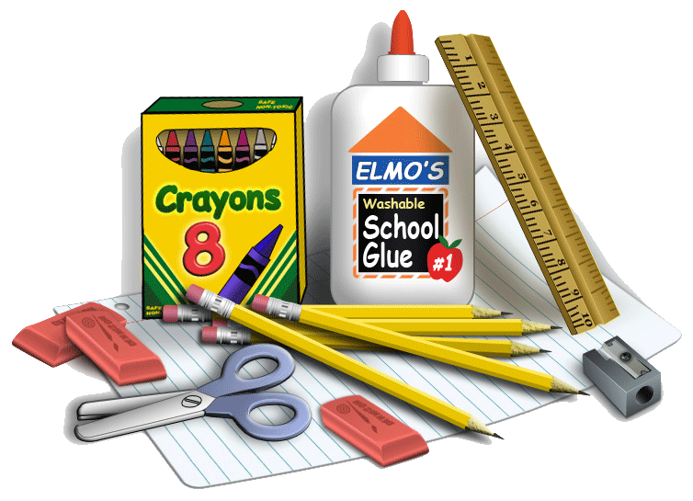

* **5 plastic folders (blue, green, red, yellow, and an alternate color of your choice)**
* **4 one subject spiral notebooks (1 blue, 1 green, 1 red, and 1 yellow)**
* **1 pair of headphones**
* **A sturdy supply box or pencil case**

Thank you for taking the time to gather these supplies. Parent support with organization will help the first few weeks run smoothly for your child. If you have any questions about the supplies, feel free to contact me.

**Our classroom could also use a few items** to help us promote healthy hygiene and a sanitary environment. If you are willing to donate any of the following items to our classroom, it would be greatly appreciated! You can bring them with you to the Open House, first day of school, or any other convenient time.

* A container (or 2) of sanitizing wipes, such as Lysol antibacterial (not baby wipes)
* A large pump bottle of hand sanitizer (not individual sizes)
* 3 large boxes of tissues

The last thing I would like you to **bring on the first day of school** will require you to use your creativity. **Please cover a cereal box with colored paper and decorate it in a way that will tell the class about you. You may use pictures, drawings, clipart, magazines, or anything you’d like. Make sure you make your name large, clear, and decorative so we know who you are. Please put at least one item inside the box that would tell us something about you.** (Where you went on vacation this summer, an award you received, something you are proud of, etc.).

**Snack**

Please pack a healthy snack (ex: a piece of fruit, crackers, cereal bar, etc.) and water or juice **every day** (including the first day of school) for your snack. The latest research on the brain and learning shows that eating foods high in protein, at the beginning of the day, helps to promote learning and increased brain activity. **Please be advised that our classroom has been designated** “**Peanut Safe**”. Therefore, please refrain from sending snacks that contain peanut products, and other nuts.

**Student Information Letter**

I am eager to know all about your child. Any information you can share with me about your child will help me better meet the needs of your child. Please take some time to write me a letter about your child and send it in with him or her on the first day of school. It’s okay to “brag.”

**Important Dates to Remember**

Bridge Valley will host an Open House for students in **August** and the first day of school for students is **August 29th!**  Our Back to School Night will be on **Tuesday, September 6th @ 7:30pm.** At that time, I will be reviewing the Fifth Grade Curriculum, my expectations for the year, and answering any questions you may have. I hope you can attend. I look forward to meeting you.

I am truly anticipating an exciting year. I can’t wait to see my new fifth graders!!! Enjoy the rest of the summer and welcome back to Bridge Valley!!

Sincerely,

**Mrs. Monica Kelly**

Mrs. Monica Kelly